MG Spreading System: What You Need to Know
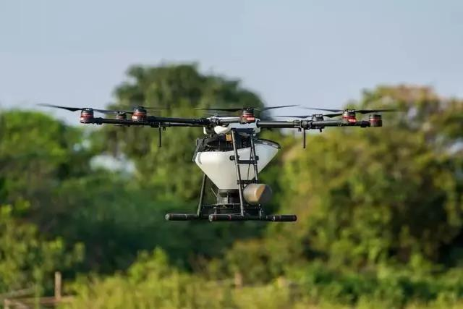

In this case study, we’re going to examine several questions relating to MG-1S and how it performs when spreading granular materials. Farmers in particular have a high demand for spreading pesticides, fertilizers, seeds, feed, snow melting agents, and more. Although DJI’s MG spreading system was built to do precisely that, numerous parameters must be set which can vary the user results.

On June 20, 2018, Professor Song from China Agricultural University led his team out into the field to test DJI’s MG-1S spreading system. We followed along to observe and document the results.

To evaluate the spreading system, we generally focused on the following questions:

- What is the optimal flight altitude when spreading material?
- What is the optimal flight speed and spinner disk rotation speed?
- What is the optimal spreading width?
- Is there any relationship between the stability of the payload flow and the opening width of the hopper gate?
- How evenly will payloads be distributed?

Test methods and measurements

In this experiment, Professor Song tested the performance of the MG spreading system using Syngenta granulated herbicide; a long-granule herbicide often used on rice fields.

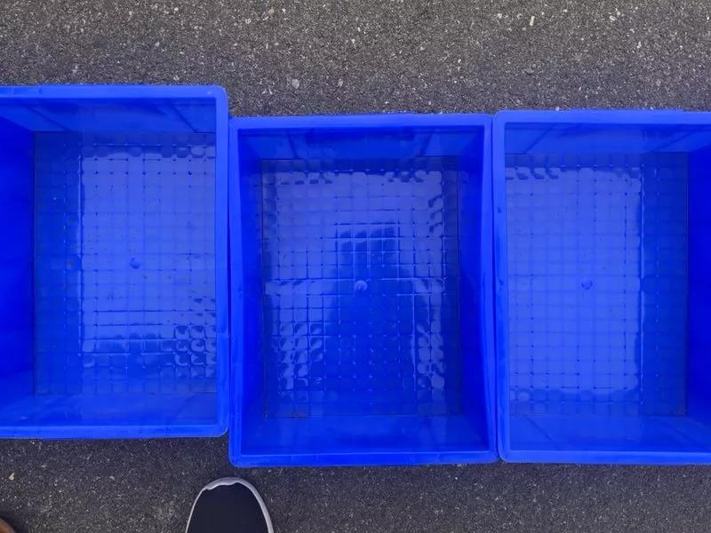

The test was conducted in an open area using an MG-1S. Professor Song arranged forty-five blue boxes in a straight line, which spanned a total length of 13.5 meters. The MG-1S flew over the boxes in a straight line while distributing materials at different heights, speeds, and other parameters to discover any resulting differences. The boxes were changed after each flight, and the test was repeated several times. The granules in each box were weighed to measure spread flows and distribution.

What effect did flying height have on spreading width?
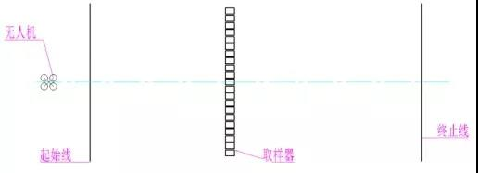
When testing flight heights, Professor Song used a flight speed of 4.5 m/s, which fell inside the 4-6 m/s recommended range for general flight operations. Professor Song then measured the effect of height on spreading width by experimenting with three flight heights: 1.5 m, 2 m, and 2.5 m. Other parameters remained constant, such as rotational speed, and an opening ratio of 25%.

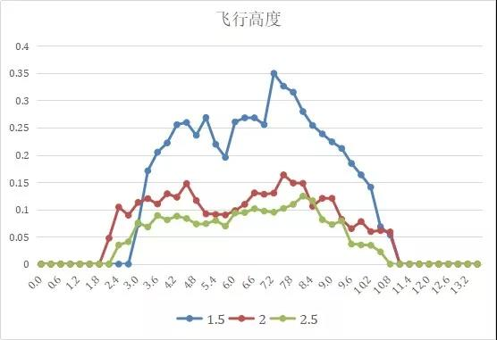

As this table shows, when the flying height was 1.5 m, the spreading width was more unstable than at 2 or 2.5 m. The table also suggests that spreading width remains relatively similar in the 2-2.5 m range. Since the difference is not significant, 2 m would appear to be an optimal flying height, especially due to the slight increase in energy efficiency.

So why is there a U-shaped distribution? As a result of the spinner disk's centrifugal force, the boxes on each end of the line received more material than those in the center. During non-linear application, however, partial overlap of flight routes will offset some of these differences and result in a more even overall distribution.

The effects of rotational speed

When we refer to the spreading system’s “rotational speed,” we’re referring to the RPM (revolutions per minute) of the spinner disk. Theoretically speaking, the faster the rotational speed, the greater the centrifugal force, and the larger the resulting width of material spreading should be.

Professor Song experimented with the spreading effects when using speeds of 800, 1069, and 1200 RPM. Other parameters remained constant during this test, such as a height of 2.5 m, a speed of 4.5 m/s, and an opening ratio set at 25%. An interesting phenomenon was discovered: although the spreading width was slightly larger at 1200 RPM, the effective spreading width of all three speeds was relatively equal (about 7.2 meters). These results suggest that RPM has little effect on spreading width. However, there were cases of uneven spreading at all three speeds. One possible reason was that material from the right side of the MG tank appeared to be distributed at a higher rate than the material on the left side, something that should be further explored by DJI.

Of the three rotational speeds observed, data suggests that 800 RPM was the least stable, while 1069 RPM was the most. This tells us that setting too low of a rotational speed may result in uneven distribution, while setting it too high may result in a waste of material.
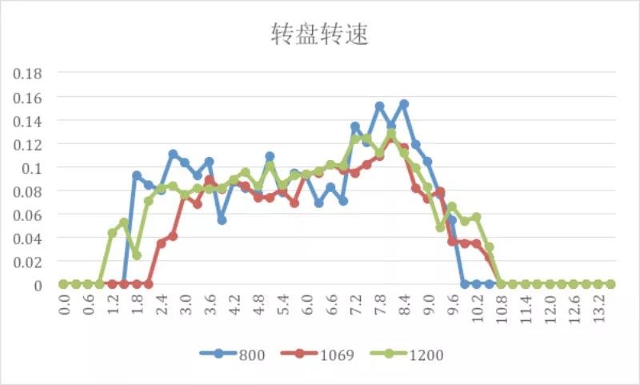

What is the suitable opening ratio of the spread tank?

Flow can be controlled by changing the opening ratio of the spread tank on the MG App. For example, 100% is completely open and 25% means 1/4 open. The larger the opening ratio, the more material is spread. Testing showed that when the opening was 100%, the flow rate averaged 3.7 kg/min, and when the opening was 25%, the flow rate averaged 1.7 kg/min.
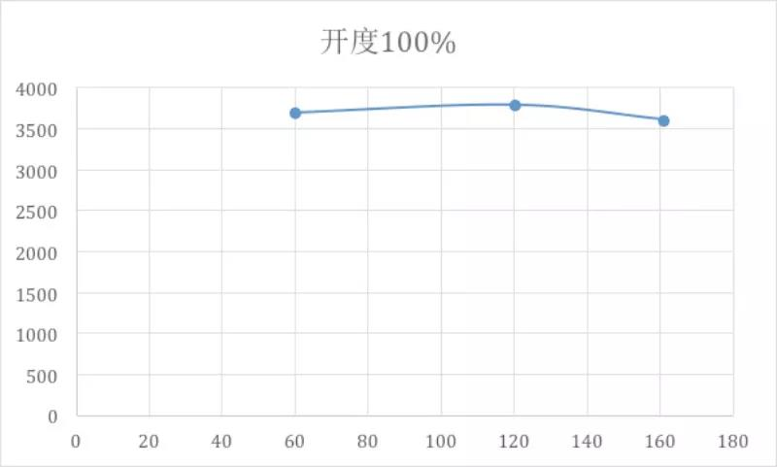
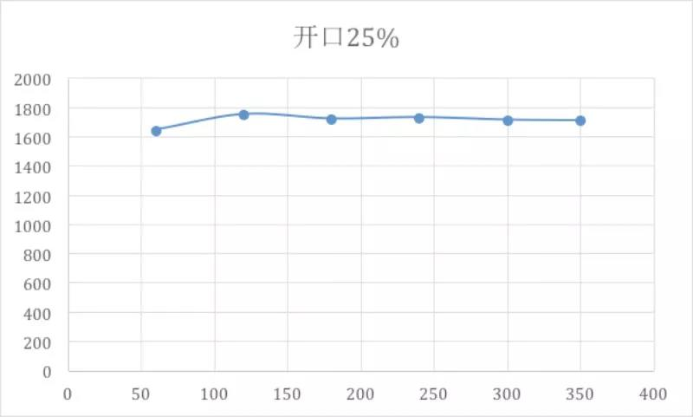

So, does the opening ratio have an effect on the spreading width of materials? Professor Song tested two cases with opening ratios of 25% and 100% at a height of 2.5 m, a speed of 4.5 m/s, and a rotational speed of 1069 RPM.

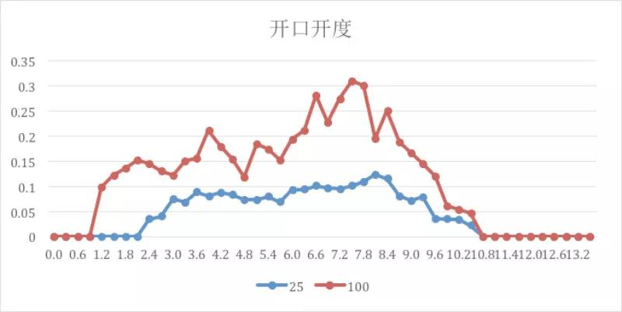

As this table shows, when the opening ratio is 100%, the spreading amount is greatly increased (compared to 25%), but the spreading width is not significantly increased. The effective spreading width at 25% was 7.2 m, and at 100% it was 7.5 m. This suggests that the opening ratio function should not be used to regulate spreading width, and instead should only be used to affect distribution per unit area.

Conclusion

For the material used in this test, optimal conditions were as follows: a spread amount of 6.07 kg/acre, a flight height of 2 m, a speed of 4.5 m/s, a rotational speed of 1069 RPM, and an opening ratio of 25%. These settings resulted in a spreading width of 7.2 m.

Although the above data is valid only for this test, and individual results may vary, it should be noted that arbitrarily increasing rotational speed does not appear to improve work efficiency in any way. When it comes to actual application and use, it is recommended that pilots and farmers conduct tests according to their working environments, materials, and needs in order to optimize the effectiveness of DJI’s MG spreading system.

